OccSpec mock task 1 Ai, Aii introduction and research.

Table of Contents

Introduction. 2

Software in the industry. 2

Apple Health 3

Google Fit. 5

Hardware in the industry. 6

Newly emerging technology. 7

Digital solutions to meet different users. 7

Industry’s specific guidelines and regulations. 7

Proposal for digital solution. 8

Business context. 8

Functional and non-functional. 8

decomposition of the problems that will need to be solved. 8

KPIs user acceptance criteria for the proposed solution. 8

Description of the proposed solution 8

Justification. 8

Meets the needs of the client. 8

Potential risks. 8

Regulatory guidelines and legal requirements. 8

Bibliography 8

# Introduction.

The client would like to have a fitness product that can help with providing information to their users, allow them to access digital content to help support their customers and encourage customers to use their products more. These are the main things that the client wants in their product. In this document I will be outlining how, software and hardware is used in health and the fitness industry, newly emerging technology, how different digital solutions can meet different user’s needs, and the industry-specific guidelines and regulations I need to follow.

* Provide information and advice for fitness training and healthy living.
* Allow access to digital content to support customers with their training and lifestyle.
* Encourage existing customers to use their services more.

The client has also provided research of their own and what people might like to see in the digital solution as well.

* Free and paid content.
* Accessibility features such as for people who have loss of sight or hearing.
* Social features.
* Customized workout and eating plans.

## Software in the industry.

There are a lots of fitness software in the world that can help with tracking exercise, calories burned, heart rate and performance. Our client could probably use a pre-existing software as there a lot of goods one that can track information like this and can send information to their customers as well. However, they might not have all the features our client wants, but it still best to research what features are beneficial and how their products function and work for a basic understating. We could take two products and comparing what advantages and disadvantages they have and how we can use them for our client or to show added risk of making a product with competition already dominating the market.

### 

### Apple Health

Apple created it first health app on September 17, 2014, and it called “Health”. It records four main data types: activity, mindfulness, sleep, and nutrition. This data is sent to the user as; health data, tracking data and medical records.

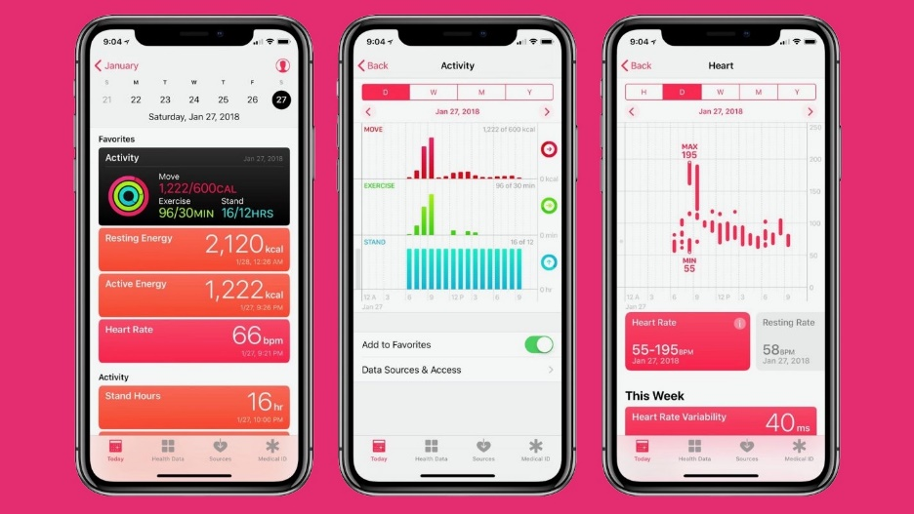

This is what Apple’s Health app looks like with the latest IOS on iPhone. It looks very clean and interactive for the user. Apple Health can only be used on IOS devices (Apple products) and can link with other devices as well like Apple watches, Apple phones and more in the apple family of products. I have a review of the product and what people like about and disliked as well as the reviews from the app store. The references can be found at the bottom of the page.

(Broadcast media Company, 2021) They said it was great at “monitoring your health and activity levels and keep track of daily habits.” It also “a good metric of daily productivity.” The pros they described were: steps tracking, flights of stairs, heart rate, sitting/idle time, and active energy. They also listed the cons they had with it as well, these included: robust tracking of food and diet, summary screen becoming convoluted, and universal comparison of days for all metrics. Overall, the reviewer said they liked the apple product and recommend them, they also gave other suggestion if it was out of your price range; such as Garmin and Fitbit.

On the apple store a lot of the review are positive about the product, they say it functions well with mostly 5-star or 4-star reviews (Reviewer, 2021). However, a lot of the reviews wrote that it was missing features that could make it better such as: medication tracker, auto track nutrient information, proper updating, more accessible on other devices, less clustered and more separated, and better tracker for sleep. It also has a very nice GUI that lays out information well but can be confusing at first if not used correctly for a new user. Here are some images below of it.

Record sleep schedule to improve sleep quality.

The heart rate monitor is good for tracking but not 100 percent like medical equipment is.

Functionalities for cycle changes and support of appetite changes.

Track how much calories you have burnt, how much exercise you have done, how long you stand. Displayed in a pie chart or sorts.

The GUI for Apple Health app on mobile looks very clean and nice, it also communicates well with-it device counterpart the Apple watch. A lot of the data can be better recorded from the watch like; burnt calories, steps walked, how many flights of stairs, and more. the GUI of the watch Is different but still looks very nice and clean.

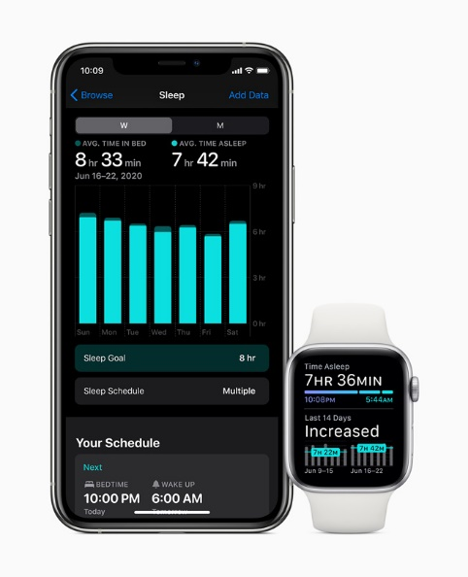 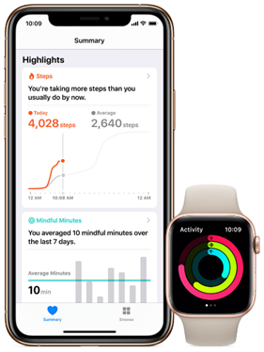 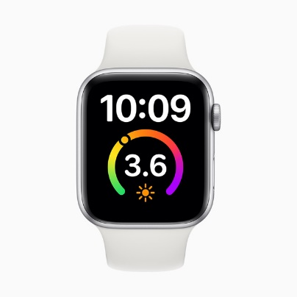

### Google Fit.

Another big fitness product is Google fit. It is owned by Alphabet inc. (Google). It is a big competitor to Apple Health. It uses smart watches like Apple but also has it own app that can be used on any android device as well as Apple devices. It called wear OS and is used by many companies including: fossil who make watches and smart watches, Samsung smart watches, Fitbit, and more.

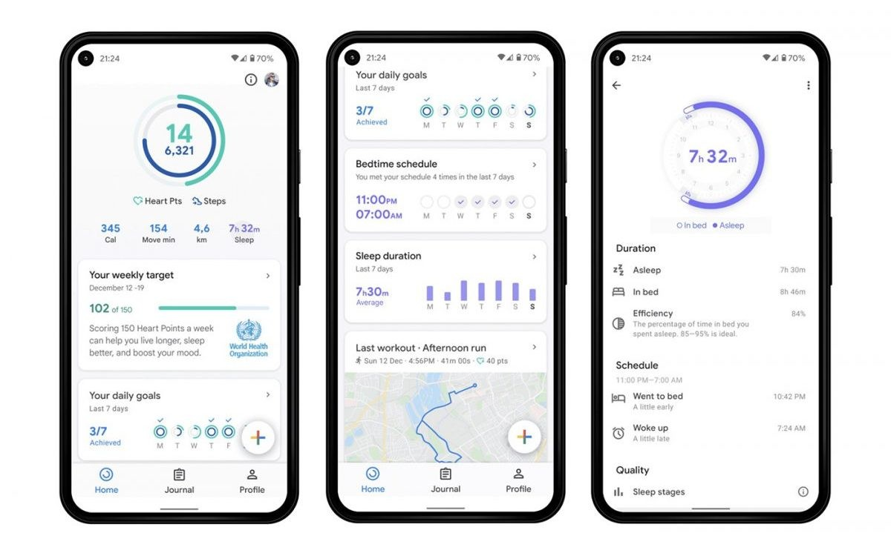

This is what Google fit looks like with the latest update, it looks clean, well structured, has lots of features that link with wear OS, has google maps integrated with it and much more for the user. The mobile app links with your devices to get data from them such as calories burnt, goals achieved, total sleep duration, GPS maps to check how far you have run, and your heart points. This can all be gathered using a smart watch that supports wear OS. Wear OS is made by Alphabet inc., it very good and responsive, has many features that can be used on the app in addition to having heart monitor support. It integrates well with android allowing you to use features such as contacts and calendars; these can be linked to both devices to allow more efficiency and ease.

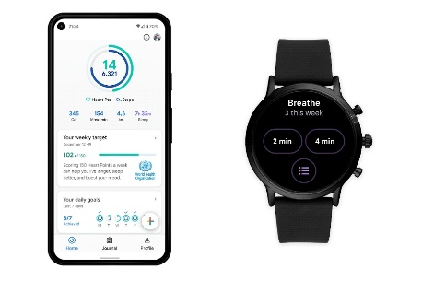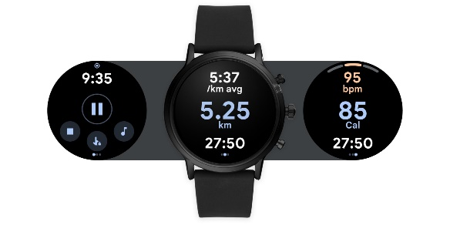

(Reviewers, n.d.) A lot of people say that app looks nice and clean, has good features, good thought behind it, the idea of heart points is good for people, and supported by most devices. Nonetheless, there are still cons to it. Has very measuring system that does not work correctly all the time, heart points are subtracted at times or added for no reason at all, heart rate points cannot be edited, does not connect sometime with other devices, and can cause lag, has had major bugs after the latest update, and more.

Overall, the google fit product is good, but has had some major problems that need to be delt with. If they are corrected soon this app would be outstanding in every way and would be very good. It one benefit is that is not exclusive to just android and can be used with Apple products. While Apple Health is only on Apple line of products. They are both good and if we are to make this product the client wants these two applications could be very useful in helping design and make the product with their clean GUI and features.

## Hardware in the industry.

Hardware in the fitness industry has started to be combined with IT to provide a beneficial machine that gives good exercise to the user, what they have done in that amount of time and create a well round healthy experience.

The main types of fitness hardware are: smart watches, treadmills, rowing machine, and more. hardware is very beneficial because unlike software it requires a human to do any of the motions. For example, smart watches can record loads of data from: heart rate, calories burnt, steps walked, miles done and more.

Another type is from a company called NordicTrack; they specialize in making exercise machine with technology built in. They have a treadmill that can adapt to your likeness. This would include the ability to raise the treadmill to create hills and make it harder to run on to increase productivity. I have linked a imagine below that shows what the treadmill looks like. It also has a built-in screen which you can control everything that the treadmill can do. Also supports third party apps; like music, movies, and social networks. (NordicTrack, n.d.)

## Newly emerging technology.

The biggest up and coming technology for exercise would probably be VR or better known as virtual reality. All it requires is a VR headset, controllers, and a room. The main companies that make them are Meta Quest, VIVE and Valve. They all make very good headsets; Meta Quest make the more affordable oculus VR headsets, VIVE make the mid to high range headsets, and Valve make there only headset which cost the most the Valve Index. They are great in their own way and can be used for many VR games.

There are many games that are fun and interactive for the user but not a lot of exercise games, the closet I could find were the games I have listed below and brief description about them. (Dingman, 2022)

* Beat Saber – a game that requires you to hit blocks in a sync with the music in the background, also requires you to dodge electrified walls to keep progressing as well. It incredibly fun for people who love music and like Star Wars; you can also change the music, and this will affect the blocks by changing the course.
* Holofit – a game that can do: running, rowing, cycling, and skiing in VR. You chose the exercise that you want to do, and you will perform the action in VR. This can range from moving your arms up and down to do running. Using the controllers as oars to do rowing in a kayak or just putting your controllers on a bike to simulate riding a bike on the open road. It very good and just requires a subscription to use.
* Space Pirate Trainer – a first person shooter that requires you to take on loads of different types of drones. The game evolves arounds you taking out as many drones with different guns from pistol, laser guns and shotguns. It also allows you to use a shield or you can dual wield and dodge fire from drones. The game is fun and heart racing requiring you to stay on your feet and move a lot to stay alive.

## Digital solutions to meet different users.

There are loads of user who need help with technology, this can range from sight to, hearing, input and output and more.

* Voice over – hovering over objects on the webpage would say what it is and what it does. This would help with people who are visually impaired.
* Tips – hovering over objects would bring up a box saying what it does and giving more information for people and for people who may have hearing impairment.
* Ergonomics – accessories that are helpful for the user like proper back support, keyboards that type well and support the user’s wrist.
* Eye strain – give messages to user to take breaks after looking at a screen for so long.
* Injury/disability – has exercises that support them and can be managed by them without getting hurt.
* Colourblind – some people might struggle to read what on the page because they are colourblind, implementing the basic colourblind choices would help these people.

## 

## Industry’s specific guidelines and regulations.

These are the main ones that I can see affecting us.

The [General Data Protection Regulation (GDPR)](https://gdpr.eu/) is the toughest privacy and security law in the world. Though it was drafted and passed by the European Union (EU), it imposes obligations onto organizations anywhere, so long as they target or collect data related to people in the EU. The regulation was put into effect on May 25, 2018. The GDPR will levy harsh fines against those who violate its privacy and security standards, with penalties reaching into the tens of millions of euros. (European Union, n.d.)

The UK GDPR provides the following rights for individuals:

1. The right to be informed
2. The right of access
3. The right to rectification
4. The right to erasure
5. The right to restrict processing
6. The right to data portability
7. The right to object
8. Rights in relation to automated decision making and profiling.

This part of the guide explains these rights. (ico., n.d.)

**The Computer Misuse Act 1990** protects personal data held by organisations from unauthorised access and modification). The act makes the following illegal:

Unauthorised access to computer material. This refers to entering a computer system without permission (hacking)

1. Unauthorised access to computer materials with intent to commit a further crime. This refers to entering a computer system to steal data or destroy a device or network (such as planting a virus)
2. Unauthorised modification of data. This refers to modifying or deleting data, and also covers the introduction of malware or spyware onto a computer (electronic vandalism and theft of information)
3. Making, supplying, or obtaining anything which can be used in computer misuse offences

These four clauses cover a range of offences including hacking, computer fraud, blackmail, and viruses. Failure to comply with the Computer Misuse Act can lead to fines and potentially imprisonment. (BBC, n.d.)

## European & British Standards (CEN Standards). The British Standard, published by the British Standards Institution (BSI), which applies to fitness products, is the EN 957 standard, which has also recently been adopted by ISO as an International Standard ISO 20957. The standard is published in 10 parts –Part 1 General applies to all products, but in addition there are specific requirements for popular equipment such as Part 6 Treadmills, Part 9 Elliptical trainers, Part 5 Bikes, Part 7 Rowers and Part 2 Strength equipment. (Howard G Davies & associates., n.d.)

# Proposal for digital solution.

## Business context.

After researching about the fitness industry, I do not believe it would be a great idea to go fourth with the product, as there are already:

* Large amounts of products in market already.
* There not a lot of interest towards this approach.
* Client can already get what they want by using another product.
* The ability to challenge other companies that have a bigger budget is very difficult.

However, there are some positives to this as:

* They already have customers that like their product.
* There is some interest for this kind of product.
* Customers who are with them would benefit instantly from it.
* As well as it a new product and could have the possibility to make a dent in the market.

## Functional and non-functional.

**Functional** requirement is what the client wants and what we need to do to make it sell.

* Provided information to the user about fitness training and healthy living
* Provide advice to the user about fitness training and healthy living.
* Provided access to digital content supporting their customers with training and healthy lifestyle.
* Encourage existing customers to use their services more.
* Meets the standard of the client.
* Can it show data to the user easily.
* Easy to navigate for the user.
* Well-structured.
* Functional on most devices e.g., google, Firefox, opera and more.
* Maintainable for other developers.
* Allow access to digital content to support customers with their training and lifestyle.

**Non-functional** is what we need to do to make it run well.

* The program can run.
* The program loads every time.
* Updated quickly.
* The program runs effectively.
* It performs well under stress.
* Updated security to protect users.
* No bugs/errors or very little on release.
* Communication between devices is good.
* Very responsive and does not crash.

## Decomposition of the problems that will need to be solved.

Problem 1 – make a system that can Provided information to the user about fitness training and healthy living

* Provide information.
* Store information.
* Save it in a suitable way.
* Fetch information.
* Display information.

Problem 2 – Provided access to digital content supporting their customers with training and healthy lifestyle.

* Display information regularly
* Easy to update.
* Fetch user data.
* Store user data.

Problem 3 – Encourage existing customers to use their services more.

* Give benefits to customers.
* Create advertisement about the product.
* Upload the advertisement.
* Store the advertisement.
* Allow compatibility with other products that [] has.
* Give special offers to pre-existing customers or people who been with the product a long time.
* Free content but less benefits/features.
* Paid content better benefits/features.

Accessibility features such as:

* Font size.
* Voice over.
* Colour theme; dark, white, normal vision, Deuteranopia, Protanopia, Tritanopia.
* Braille keyboards.
* Braille display.

## 

## KPIs user acceptance criteria for the proposed solution.

I have made simple table outlining what the client wants and how we will go about making it in a brief description.

|  |  |  |
| --- | --- | --- |
| Row # | Task to perform. | User acceptance criteria. |
| 1 | Create software that can send information to the user about fitness and health. | Send information to users about fitness and health. |
| 2 | Create software that allows access to digital content and provides support to customers. | Create a website or app to view content. |
| 3 | Create software that benefits pre-existing costumers with better features. | Encourage pre-existing customers to use more of their products. |

## 

Some KPIs that might be involved are:

* Test coverage – how much code is executed during the test.
* Stability – percentage of the code that working.
* Code simplicity – the code readable and maintainable.
* Code churn – percentage of the code that must be written and could cause risk.
* Velocity – how fast the code it at deployment.

## Description of the proposed solution

If we are to make a product that meets the client specifications, I think we should make a website that can display information that the client would want to put on, what health and fitness choices they can do and make a membership system that benefits pre-existing customers such as better information or more loyalty roll. We could possibly add the features that client recommends us from research but it best to do the main 3 and worry about other features later. We can take aspiration from NordicTrack as their website is very nice and clean, it also lays out the information well in a good structure. I believe we could add an email system to send information to users about the products or responded if they need help.

## 

## Justification.

### 

### Meets the needs of the client.

Provide information and advice for fitness training

Provide information and advice for healthy living.

Allow access to digital content.

Digital support for customers with their training and lifestyle.

Encourage existing customers to use their services more, this could be something of a membership.

### Potential risks.

* Insufficient amount of budget.
* Insufficient amount of time.
* Large competition in the market.
* Lack of knowledge.
* Chances of Push backs.
* Possibly a Bad launch.
* Release a product that unfinished

I would say these are the main risks involved with this project.

### 

### Regulatory guidelines and legal requirements.

* GDPR (General Data Protection Regulation)
* Computer Misuse Act 1990.
* DES Workstation Assessments.
* Eye test requests.
* Workstation risk Assessment.

# Bibliography

BBC. (n.d.). *Ethical, legal, and environmental impact - CCEA*. Retrieved from Bitesize: https://www.bbc.co.uk/bitesize/guides/z8m36yc/revision/5

Broadcast media Company. (2021, July 23). *Take a bit out of your daily fitness goals woth Apple Health*. Retrieved from TrustRadius: https://www.trustradius.com/reviews/apple-health-2021-07-20-09-54-31

Dingman, H. (2022, January 12). *Exercise by accident: VR games to help you work out at home.* Retrieved from Meta Quest: https://www.oculus.com/blog/exercise-by-accident-vr-games-to-help-you-work-out-at-home/?locale=en_GB

European Union. (n.d.). *What is GDPR, the EU'S new data protection law?* Retrieved from GDPR.EU: https://gdpr.eu/what-is-gdpr/

Howard G Davies & associates. (n.d.). *Fitness Industry Regulations.* Retrieved from Howard G Davies & associates, Fitness Equipment Safety Consultants.: http://www.howardgdaviesassociates.co.uk/standards

ico. (n.d.). *Individual rights*. Retrieved from Information commissloner's office: https://ico.org.uk/for-organisations/guide-to-data-protection/guide-to-the-general-data-protection-regulation-gdpr/individual-rights/

NordicTrack. (n.d.). *NordicTrack*. Retrieved from What technologies are intregrated into your treadmill?: https://www.nordictrack.co.uk/learn/what-technologies-are-integrated-your-treadmill/

Reviewer. (2021). *Apple Store Preview*. Retrieved from Apple: https://apps.apple.com/us/app/apple-health/id1242545199

Reviewers. (n.d.). *Play Store*. Retrieved from Google FIt Play Store: https://play.google.com/store/apps/details?id=com.google.android.apps.fitness&hl=en_GB&gl=US